ЛАБОРАТОРНА РОБОТА № 2

АДМІНІСТРУВАННЯ БД
Мета: навчитися досліджувати БД за допомогою T-SQL

Хід роботи:

Досліджуємо сервер
Лістинг програми:
Select @@SERVERNAME as [Server\Instance];
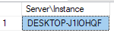
Select @@VERSION as SQLServerVersion;
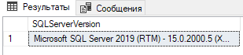
Select @@ServiceName AS ServiceInstance;
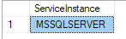
Select DB_NAME() AS CurrentDB_Name;
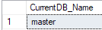

Час останнього перезапуску сервера
Лістинг програми:
SELECT @@Servername AS ServerName ,
create_date AS ServerStarted ,
DATEDIFF(s, create_date, GETDATE()) / 86400.0 AS DaysRunning ,
DATEDIFF(s, create_date, GETDATE()) AS SecondsRunnig
FROM sys.databases
WHERE name = 'tempdb';
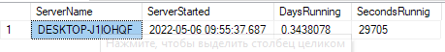

Чи є ваш сервер баз даних ізольованим від інших, або він пов'язаний з іншими серверами
Лістинг програми:
EXEC sp_helpserver;

EXEC sp_linkedservers;

SELECT @@SERVERNAME AS Server ,
Server_Id AS LinkedServerID ,
name AS LinkedServer ,
Product ,
Provider ,
Data_Source ,
Modify_Date
FROM sys.servers
ORDER BY name;

\

Список всіх баз даних
Лістинг програми:
EXEC sp_helpdb;
--OR

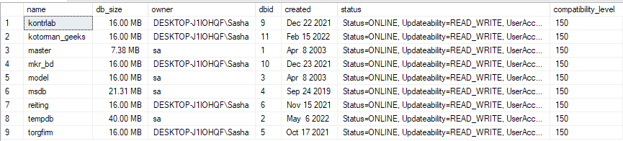

EXEC sp_Databases;
--OR
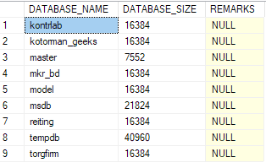

SELECT @@SERVERNAME AS Server ,
name AS DBName ,
recovery_model_Desc AS RecoveryModel ,
Compatibility_level AS CompatiblityLevel ,
create_date ,
state_desc
FROM sys.databases
ORDER BY Name;
--OR
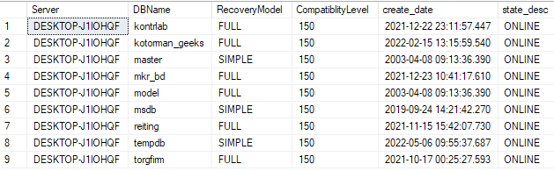

SELECT @@SERVERNAME AS Server ,
d.name AS DBName ,
create_date ,
compatibility_level ,
m.physical_name AS FileName
FROM sys.databases d
JOIN sys.master_files m ON d.database_id = m.database_id
WHERE m.[type] = 0 -- data files only
ORDER BY d.name;

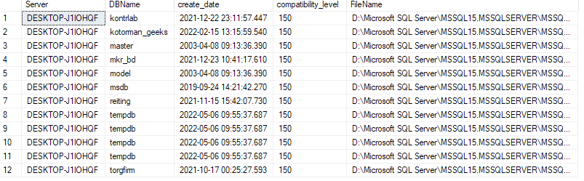
Рис. 12 Результат виконання програми
Вивчаємо бази даних
- Системна таблиця sys.objects одна з ключових для збору інформації про об'єкти, що становлять вашу модель даних.
USE kotorman_geeks;
SELECT * FROM sys.objects
WHERE type = 'F';
Результат виконання програми:

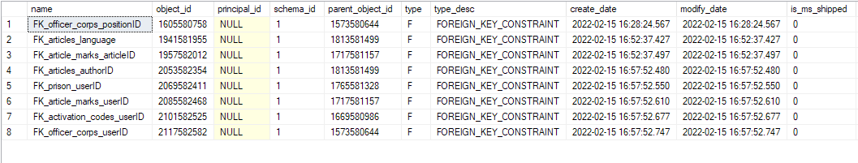
Розташування файлів баз даних.
Лістинг програми:
EXEC sp_Helpfile;

SELECT @@Servername AS Server ,
DB_NAME() AS DB_Name ,
File_id ,
Type_desc ,
Name ,
LEFT(Physical_Name, 1) AS Drive ,
Physical_Name ,
RIGHT(physical_name, 3) AS Ext ,
Size ,
Growth
FROM sys.database_files
ORDER BY File_id;

Досліджуємо таблиці.
Лістинг програми:
EXEC sp_tables;

Результат виконання програми:
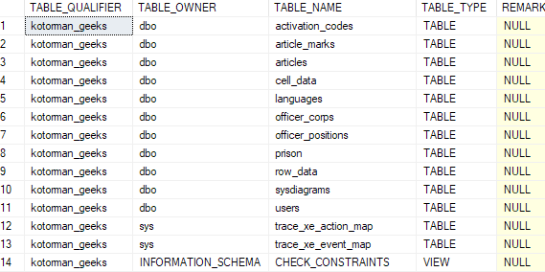

SELECT @@Servername AS ServerName ,
TABLE_CATALOG ,
TABLE_SCHEMA ,
TABLE_NAME
FROM INFORMATION_SCHEMA.TABLES
WHERE TABLE_TYPE = 'BASE TABLE'
ORDER BY TABLE_NAME ;
--OR

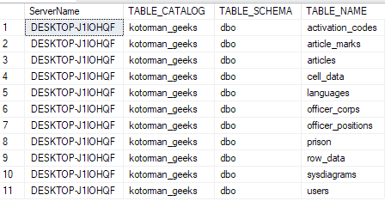

SELECT @@Servername AS ServerName ,
DB_NAME() AS DBName ,
o.name AS 'TableName' ,
o.[Type] ,
o.create_date
FROM sys.objects o
WHERE o.Type = 'U' -- User table
ORDER BY o.name;

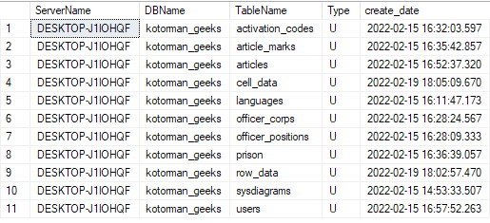

SELECT @@Servername AS ServerName ,
DB_NAME() AS DBName ,
t.Name AS TableName,
t.[Type],
t.create_date
FROM sys.tables t
ORDER BY t.Name;

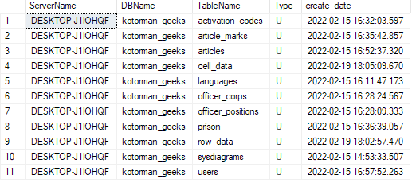

Кількість записів в таблиці
Лістинг програми:
SELECT 'Select ''' + DB_NAME() + '.' + SCHEMA_NAME(SCHEMA_ID) + '.'
+ LEFT(o.name, 128) + ''' as DBName, count(*) as Count From ' + SCHEMA_NAME(SCHEMA_ID) + '.' + o.name
+ ';' AS ' Counts for all tables'
FROM sys.objects o
WHERE o.[type] = 'U'
ORDER BY o.name;
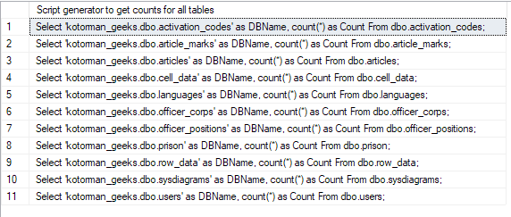

Select 'kotorman_geeks.dbo.users' as DBName, count(*) as Count From users;
Select 'kotorman_geeks.articles' as DBName, count(*) as Count From articles;

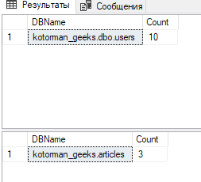

Розбираємося з активністю в таблиці
Лістинг програми:
SELECT @@ServerName AS ServerName ,
DB_NAME() AS DBName ,
OBJECT_NAME(ddius.object_id) AS TableName ,
SUM(ddius.user_seeks + ddius.user_scans + ddius.user_lookups)
AS Reads ,
SUM(ddius.user_updates) AS Writes ,
SUM(ddius.user_seeks + ddius.user_scans + ddius.user_lookups
+ ddius.user_updates) AS [Reads&Writes] ,
( SELECT DATEDIFF(s, create_date, GETDATE()) / 86400.0
FROM master.sys.databases
WHERE name = 'tempdb'
) AS SampleDays ,
( SELECT DATEDIFF(s, create_date, GETDATE()) AS SecoundsRunnig
FROM master.sys.databases
WHERE name = 'tempdb'
) AS SampleSeconds
FROM sys.dm_db_index_usage_stats ddius
INNER JOIN sys.indexes i ON ddius.object_id = i.object_id
AND i.index_id = ddius.index_id
WHERE OBJECTPROPERTY(ddius.object_id, 'IsUserTable') = 1
AND ddius.database_id = DB_ID()
GROUP BY OBJECT_NAME(ddius.object_id)
ORDER BY [Reads&Writes] DESC;

Розбираємося з активністю в таблиці (представлено курсором)
Лістинг програми:
DECLARE DBNameCursor CURSOR
FOR
SELECT Name
FROM sys.databases
WHERE Name NOT IN ( 'master', 'model', 'msdb', 'tempdb',
'distribution' )
ORDER BY Name;
DECLARE @DBName NVARCHAR(128)
DECLARE @cmd VARCHAR(4000)
IF OBJECT_ID(N'tempdb..TempResults') IS NOT NULL
BEGIN
DROP TABLE tempdb..TempResults
END
CREATE TABLE tempdb..TempResults
(
ServerName NVARCHAR(128) ,
DBName NVARCHAR(128) ,
TableName NVARCHAR(128) ,
Reads INT ,
Writes INT ,
ReadsWrites INT ,
SampleDays DECIMAL(18, 8) ,
SampleSeconds INT
)
OPEN DBNameCursor
FETCH NEXT FROM DBNameCursor INTO @DBName
WHILE @@fetch_status = 0
BEGIN
SELECT @cmd = 'Use ' + @DBName + '; '
SELECT @cmd = @cmd + ' Insert Into tempdb..TempResults
SELECT @@ServerName AS ServerName,
DB_NAME() AS DBName,
object_name(ddius.object_id) AS TableName ,
SUM(ddius.user_seeks
+ ddius.user_scans
+ ddius.user_lookups) AS Reads,
SUM(ddius.user_updates) as Writes,
SUM(ddius.user_seeks
+ ddius.user_scans
+ ddius.user_lookups
+ ddius.user_updates) as ReadsWrites,
(SELECT datediff(s,create_date, GETDATE()) / 86400.0
FROM sys.databases WHERE name = ''tempdb'') AS SampleDays,
(SELECT datediff(s,create_date, GETDATE())
FROM sys.databases WHERE name = ''tempdb'') as SampleSeconds
FROM sys.dm_db_index_usage_stats ddius
INNER JOIN sys.indexes i
ON ddius.object_id = i.object_id
AND i.index_id = ddius.index_id
WHERE objectproperty(ddius.object_id,''IsUserTable'') = 1 --True
AND ddius.database_id = db_id()
GROUP BY object_name(ddius.object_id)
ORDER BY ReadsWrites DESC;'
EXECUTE (@cmd)
FETCH NEXT FROM DBNameCursor INTO @DBName
END
CLOSE DBNameCursor
DEALLOCATE DBNameCursor
SELECT *
FROM tempdb..TempResults
ORDER BY DBName ,
TableName;

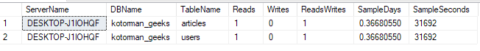

Досліджуємо відображення.
Лістинг програми:
SELECT @@Servername AS ServerName ,
DB_NAME() AS DBName ,
o.name AS ViewName ,
o.[Type] ,
o.create_date
FROM sys.objects o
WHERE o.[Type] = 'V' -- View
ORDER BY o.NAME
--OR

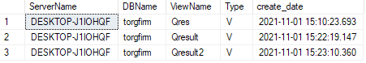

SELECT @@Servername AS ServerName ,
DB_NAME() AS DBName ,
Name AS ViewName ,
create_date
FROM sys.Views
ORDER BY Name
--OR

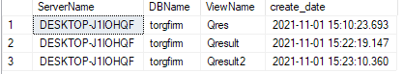
SELECT @@Servername AS ServerName ,
TABLE_CATALOG ,
TABLE_SCHEMA ,
TABLE_NAME ,
TABLE_TYPE
FROM INFORMATION_SCHEMA.TABLES
WHERE TABLE_TYPE = 'VIEW'
ORDER BY TABLE_NAME
--OR

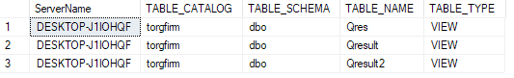

-- CREATE VIEW Code
SELECT @@Servername AS ServerName ,
DB_NAME() AS DB_Name ,
o.name AS 'ViewName' ,
o.Type ,
o.create_date ,
sm.[DEFINITION] AS 'View script'
FROM sys.objects o
INNER JOIN sys.sql_modules sm ON o.object_id = sm.OBJECT_ID
WHERE o.Type = 'V' -- View
ORDER BY o.NAME;

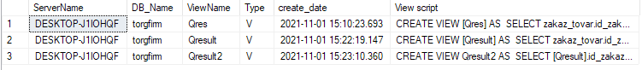

Дослідити процедури, що зберігаються.
Лістинг програми:
SELECT @@Servername AS ServerName ,
DB_NAME() AS DBName ,
o.name AS StoredProcedureName ,
o.[Type] ,
o.create_date
FROM sys.objects o
WHERE o.[Type] = 'P' -- Stored Procedures
ORDER BY o.name

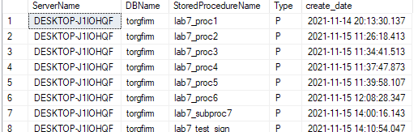

Лістинг програми:
SELECT @@Servername AS ServerName ,
DB_NAME() AS DB_Name ,
o.name AS 'ViewName' ,
o.[type] ,
o.Create_date ,
sm.[definition] AS 'Stored Procedure script'
FROM sys.objects o
INNER JOIN sys.sql_modules sm ON o.object_id = sm.object_id
WHERE o.[type] = 'P' -- Stored Procedures
-- AND sm.[definition] LIKE '%insert%'
-- AND sm.[definition] LIKE '%update%'
-- AND sm.[definition] LIKE '%delete%'
-- AND sm.[definition] LIKE '%tablename%'
ORDER BY o.name;

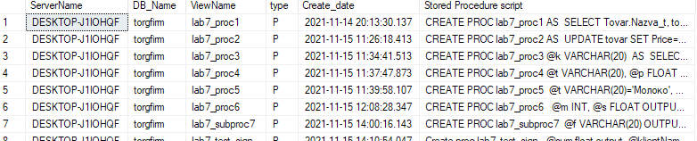

Дослідити функції.
Лістинг програми:
SELECT @@Servername AS ServerName ,
DB_NAME() AS DB_Name ,
o.name AS 'Functions' ,
o.[Type] ,
o.create_date
FROM sys.objects o
WHERE o.Type = 'FN' -- Function
ORDER BY o.NAME;

Лістинг програми:

SELECT @@Servername AS ServerName ,
DB_NAME() AS DB_Name ,
o.name AS 'FunctionName' ,
o.[type] ,
o.create_date ,
sm.[DEFINITION] AS 'Function script'
FROM sys.objects o
INNER JOIN sys.sql_modules sm ON o.object_id = sm.OBJECT_ID
WHERE o.[Type] = 'FN' -- Function
ORDER BY o.NAME;

Дослідити тригери.
Лістинг програми:
SELECT @@Servername AS ServerName ,
DB_NAME() AS DBName ,
parent.name AS TableName ,
o.name AS TriggerName ,
o.[Type] ,
o.create_date
FROM sys.objects o
INNER JOIN sys.objects parent ON o.parent_object_id = parent.object_id
WHERE o.Type = 'TR' -- Triggers
ORDER BY parent.name ,
o.NAME

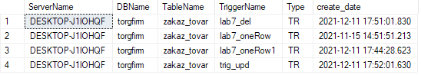
Лістинг програми:
SELECT @@Servername AS ServerName ,
DB_NAME() AS DB_Name ,
Parent_id ,
name AS TriggerName ,
create_date
FROM sys.triggers
WHERE parent_class = 1
ORDER BY name;

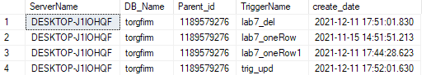

--OR
-- Додаткова інформація по тригерах
SELECT @@Servername AS ServerName ,
DB_NAME() AS DB_Name ,
OBJECT_NAME(Parent_object_id) AS TableName ,
o.name AS 'TriggerName' ,
o.Type ,
o.create_date ,
sm.[DEFINITION] AS 'Trigger script'
FROM sys.objects o
INNER JOIN sys.sql_modules sm ON o.object_id = sm.OBJECT_ID
WHERE o.Type = 'TR' -- Triggers
ORDER BY o.NAME;

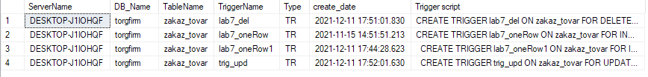
CHECK-обмеження.
Лістинг програми:
SELECT @@Servername AS ServerName ,
DB_NAME() AS DBName ,
parent.name AS 'TableName' ,
o.name AS 'Constraints' ,
o.[Type] ,
o.create_date
FROM sys.objects o
INNER JOIN sys.objects parent
ON o.parent_object_id = parent.object_id
WHERE o.Type = 'C' -- Check Constraints
ORDER BY parent.name ,
o.name

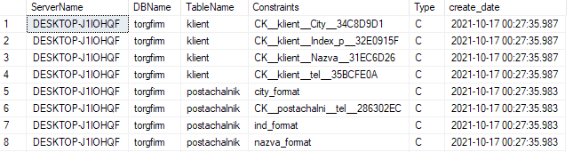

SELECT @@Servername AS ServerName ,
DB_NAME() AS DBName ,
OBJECT_SCHEMA_NAME(parent_object_id) AS SchemaName ,
OBJECT_NAME(parent_object_id) AS TableName ,
parent_column_id AS Column_NBR ,
Name AS CheckConstraintName ,
type ,
type_desc ,
create_date ,
OBJECT_DEFINITION(object_id) AS CheckConstraintDefinition
FROM sys.Check_constraints
ORDER BY TableName ,
SchemaName ,
Column_NBR

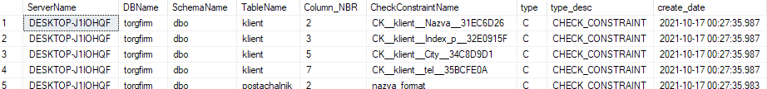

Модель даних.
Лістинг програми:
SELECT @@Servername AS Server ,
DB_NAME() AS DBName ,
isc.Table_Name AS TableName ,
isc.Table_Schema AS SchemaName ,
Ordinal_Position AS Ord ,
Column_Name ,
Data_Type ,
Numeric_Precision AS Prec ,
Numeric_Scale AS Scale ,
Character_Maximum_Length AS LEN , -- -1 means MAX like Varchar(MAX)
Is_Nullable ,
Column_Default ,
Table_Type
FROM INFORMATION_SCHEMA.COLUMNS isc
INNER JOIN information_schema.tables ist
ON isc.table_name = ist.table_name
-- WHERE Table_Type = 'BASE TABLE' -- 'Base Table' or 'View'
ORDER BY DBName ,
TableName ,
SchemaName ,
Ordinal_position;

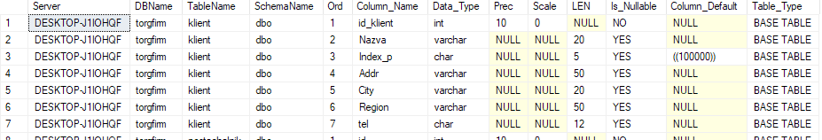

-- Кількість повторів
SELECT @@Servername AS Server ,
DB_NAME() AS DBName ,
Column_Name ,
Data_Type ,
Numeric_Precision AS Prec ,
Numeric_Scale AS Scale ,
Character_Maximum_Length ,
COUNT(*) AS Count
FROM information_schema.columns isc
INNER JOIN information_schema.tables ist
ON isc.table_name = ist.table_name
WHERE Table_type = 'BASE TABLE'
GROUP BY Column_Name ,
Data_Type ,
Numeric_Precision ,
Numeric_Scale ,
Character_Maximum_Length;

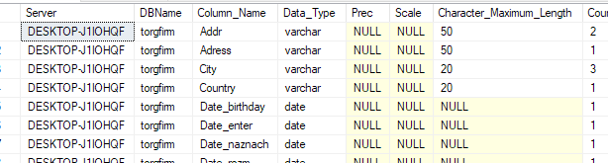

SELECT @@Servername AS ServerName ,
DB_NAME() AS DBName ,
Data_Type ,
Numeric_Precision AS Prec ,
Numeric_Scale AS Scale ,
Character_Maximum_Length AS [Length] ,
COUNT(*) AS COUNT
FROM information_schema.columns isc
INNER JOIN information_schema.tables ist
ON isc.table_name = ist.table_name
WHERE Table_type = 'BASE TABLE'
GROUP BY Data_Type ,
Numeric_Precision ,
Numeric_Scale ,
Character_Maximum_Length
ORDER BY Data_Type ,
Numeric_Precision ,
Numeric_Scale ,
Character_Maximum_Length

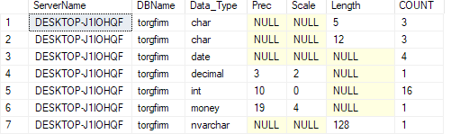

SELECT @@Servername AS ServerName ,
DB_NAME() AS DBName ,
isc.Table_Name ,
Ordinal_Position AS Ord ,
Column_Name ,
Data_Type AS BLOB_Data_Type ,
Numeric_Precision AS Prec ,
Numeric_Scale AS Scale ,
Character_Maximum_Length AS [Length]
FROM information_schema.columns isc
INNER JOIN information_schema.tables ist
ON isc.table_name = ist.table_name
WHERE Table_type = 'BASE TABLE'
AND ( Data_Type IN ( 'text', 'ntext', 'image', 'XML' )
OR ( Data_Type IN ( 'varchar', 'nvarchar', 'varbinary' )
AND Character_Maximum_Length = -1
)
)
ORDER BY isc.Table_Name ,
Ordinal_position;

SELECT @@Servername AS ServerName ,
DB_NAME() AS DBName ,
OBJECT_SCHEMA_NAME(object_id) AS SchemaName ,
OBJECT_NAME(object_id) AS Tablename ,
Column_id ,
Name AS Computed_Column ,
[Definition] ,
is_persisted
FROM sys.computed_columns
ORDER BY SchemaName ,
Tablename ,
[Definition];

SELECT @@Servername AS ServerName ,
DB_NAME() AS DBName ,
OBJECT_SCHEMA_NAME(t.object_id) AS SchemaName,
t.Name AS TableName ,
c.Column_ID AS Ord ,
c.Name AS Computed_Column
FROM sys.Tables t
INNER JOIN sys.Columns c ON t.object_id = c.object_id
WHERE is_computed = 1
ORDER BY t.Name ,
SchemaName ,
c.Column_ID

Висновки: В ході лабораторної роботи було навчено досліджувати БД за допомогою T-SQL.

